Access scratch through this link : <https://snap.berkeley.edu/snap/snap.html>

Link to final project: <https://snap.berkeley.edu/snap/snap.html#present:Username=barrettb2&ProjectName=DrawingACode&editMode&noRun>

1. Click on the control section and pull the when green flag clicked block into the center of the console.

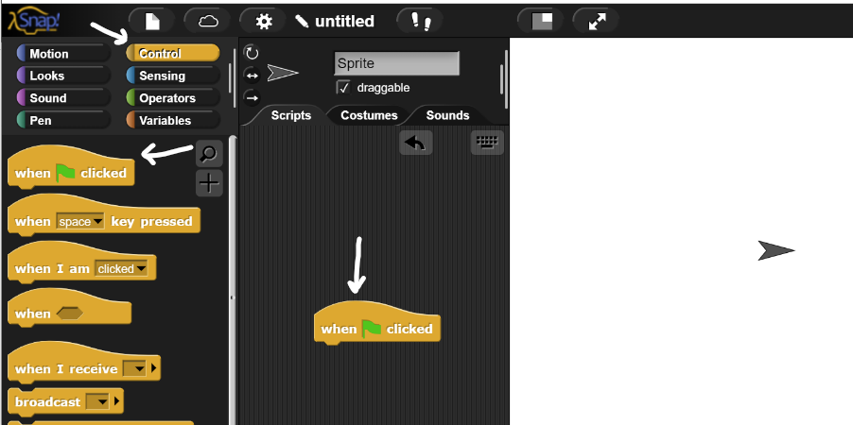

2. Click into the pen section and pull the pen up block to the center of the console and attach to the when green flag clicked block.

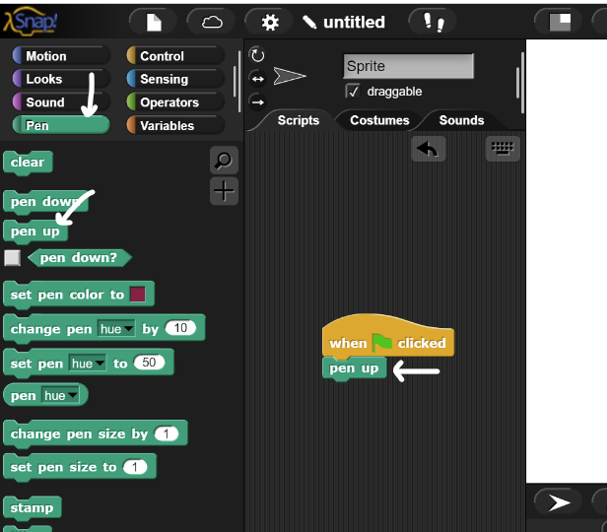

3. Click into the motion section and pull the glide block in the snippet below to the center of the console and attach to the pen up block.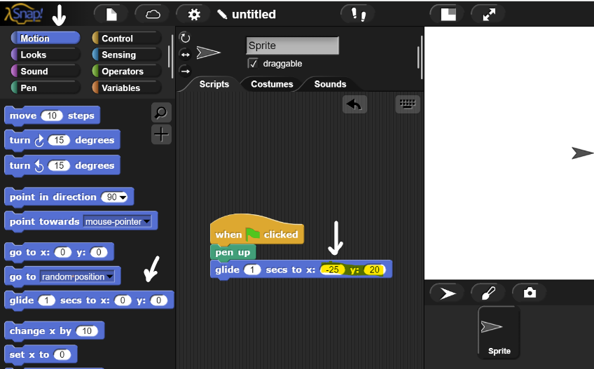

4. Click into the make a variable block when prompted variable name enter A and click okay. Once a variable is made, unclick the box on the left of the variable which will be stored in the left toolbar.

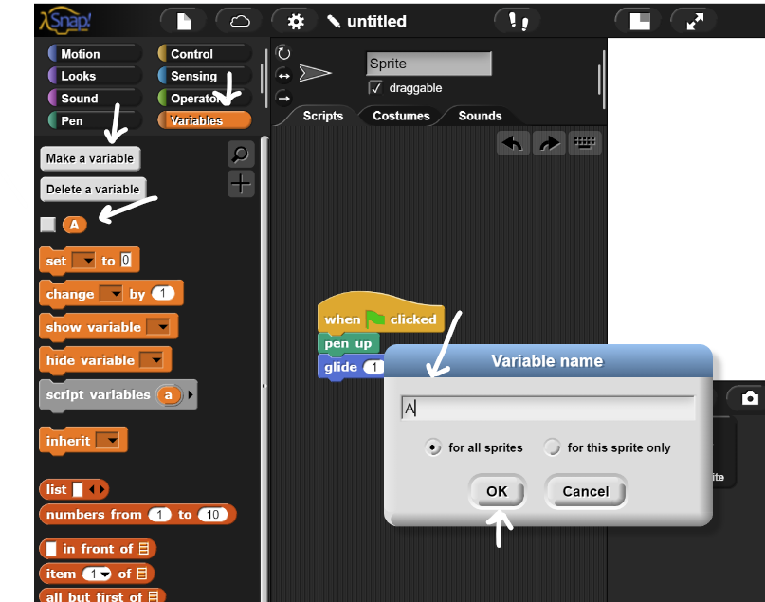

5. Click into the variables block and drag the set block to be connected to the glide block. When attached click on the upside arrow in the rectangle box on the right of the set block and change it to A.

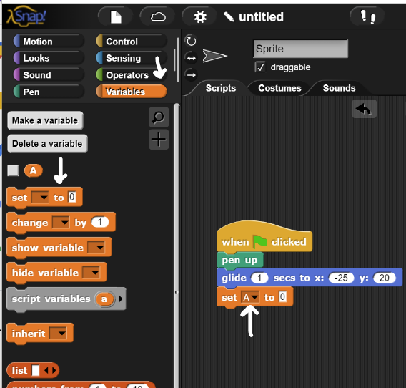

6. Click on the variable category and pull the list bubble in. Press the left arrow 8 times.

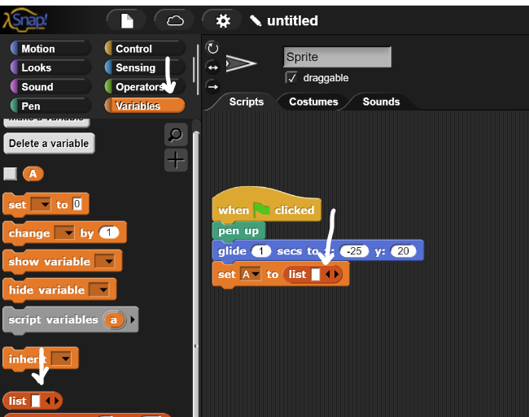

7. Click on the variable category and pull the list bubble in the center console. Press the right arrow to make two rectangles on the right of the list.

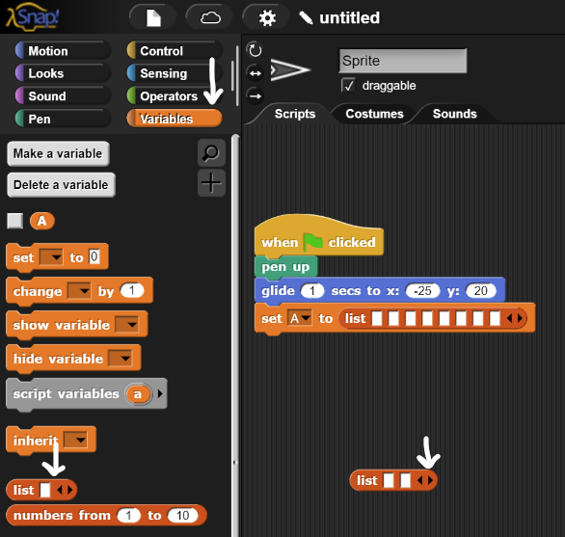

8. Go on the list bubble and right click on the bubble and press duplicate to make 8 of the blocks.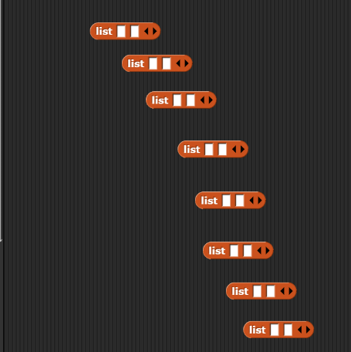

9. Drag each list into the 8 spaces made into step 7.

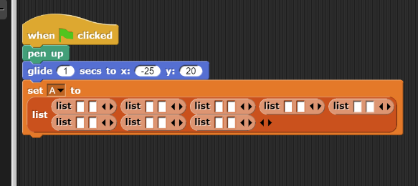

10. In each white space write -50, 20, -10, 120, 10, 120, 50, 20, 30, 20, 20, 50, -20, 50, -30, and 20.

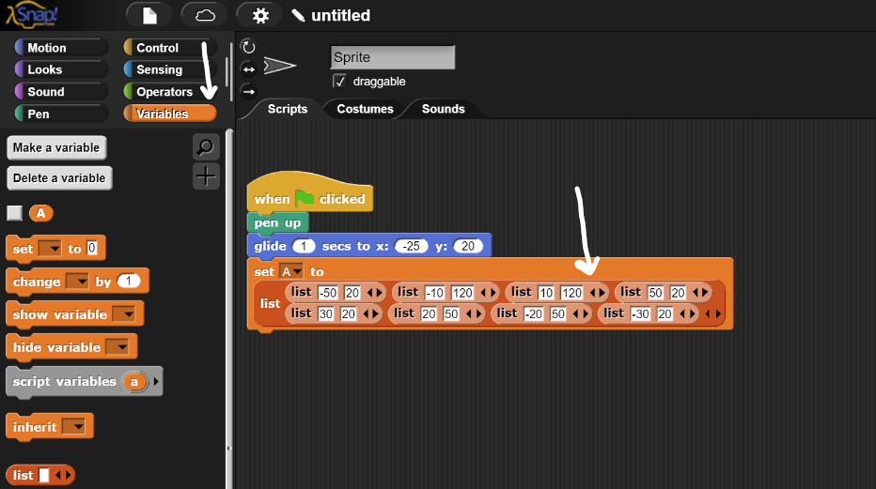

11. Go to the pen category and drag the clear block under the set block.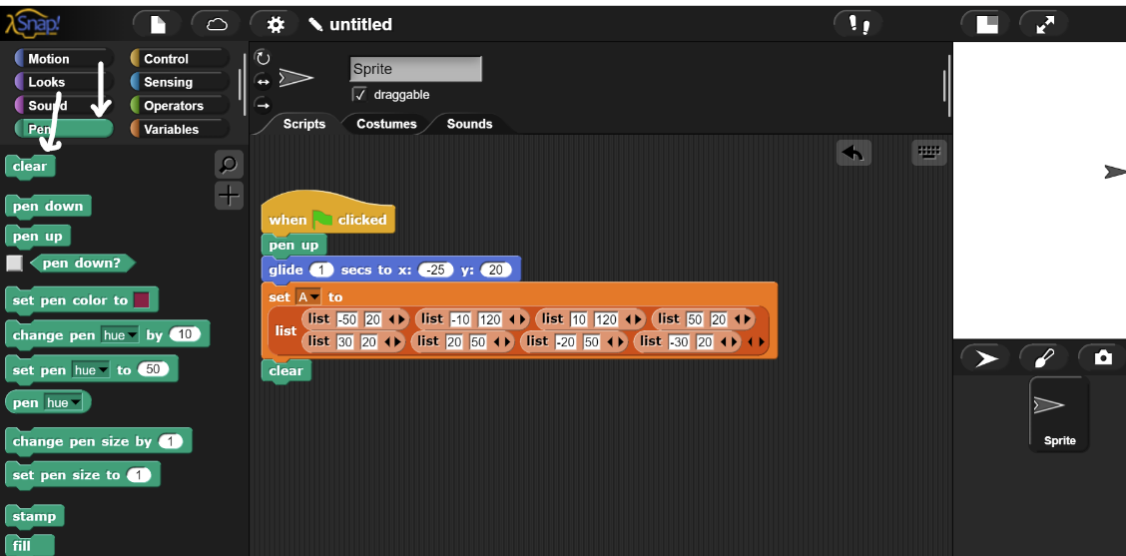

12. Go to the pen category and drag the pen down under the clear block.

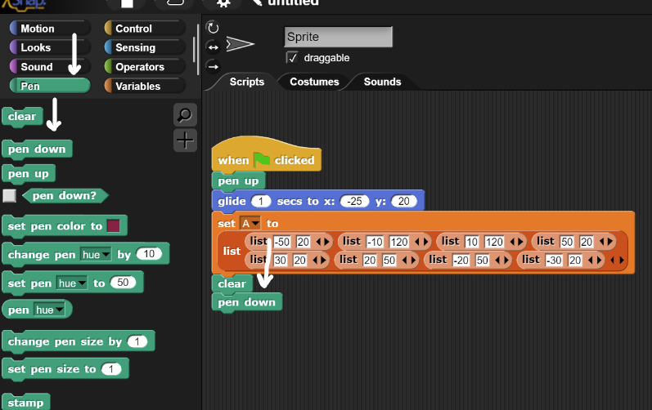

13. Go to the variables category and drag the for each block under the pen down block. Drag the variable you created in earlier steps A in the circle inside the for each block.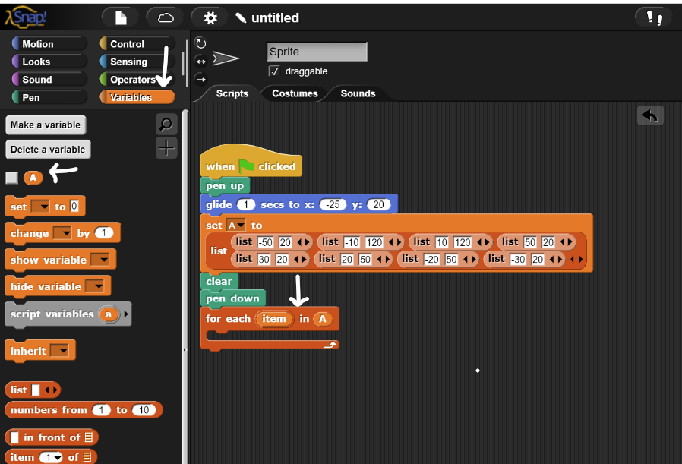

14. Go to the sensing category and click make a block in the block type “go to point” press okay. Then press the plus arrow on the right of the point work. Then type in the text box point. Then go into the motion category and drag the glide block under the created block.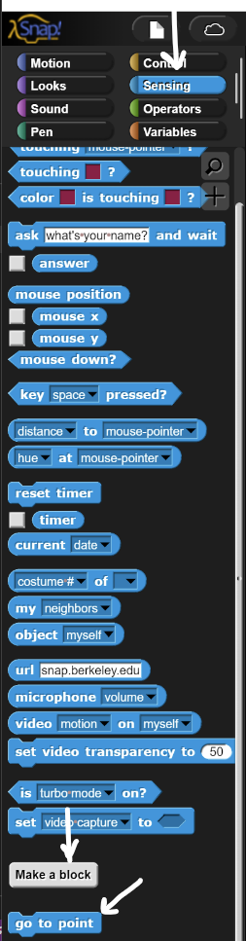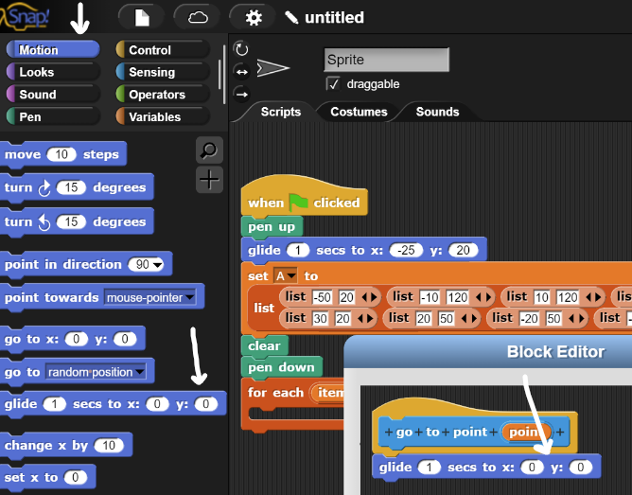

15. Go to variables and put two item blocks in the x and y. Then press on the circle in the second item to the blank value and enter 2. In addition drag the point variable in the top block in each item block after the “of”. Then press ok.

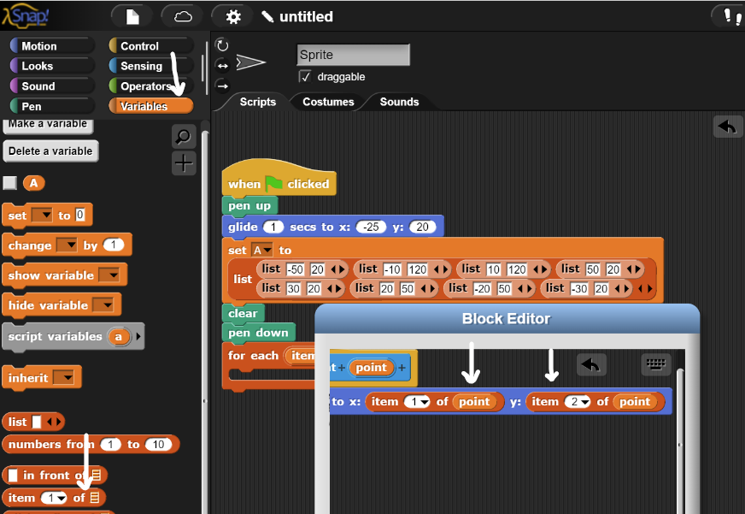

16. Then go to the sensing category and pull the go to point block into the for each block. Pull the item variable into the rectangle in the go to point block.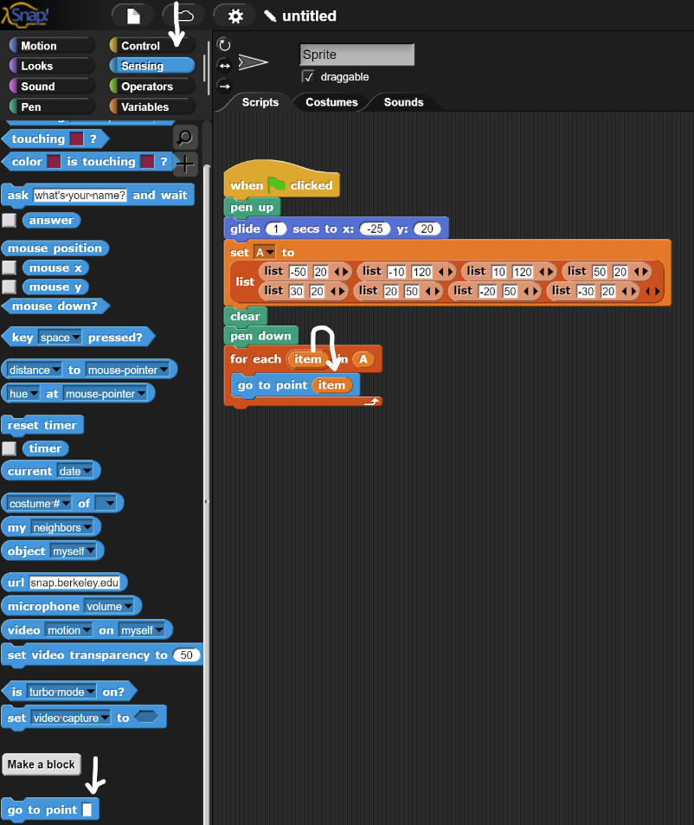

17. Then go to the pen category and drag the pen up block attached to the for each block.

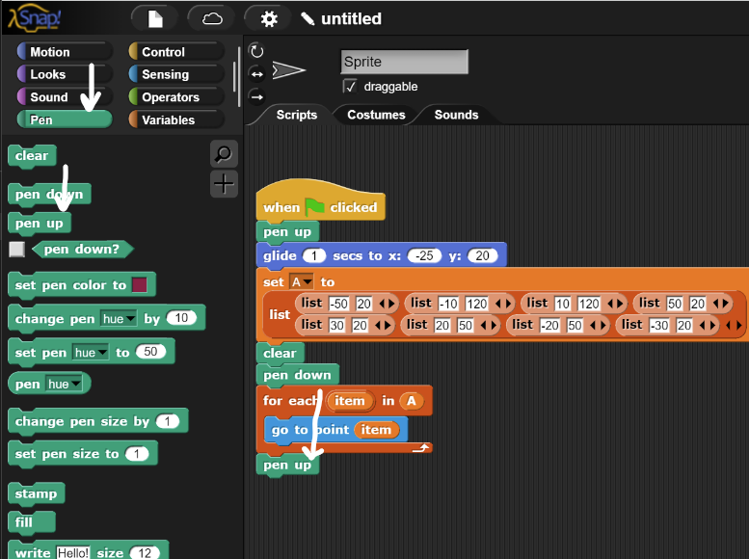

18. Go into the motion category and pull the glide block to attach to the bottom of the pen up block.

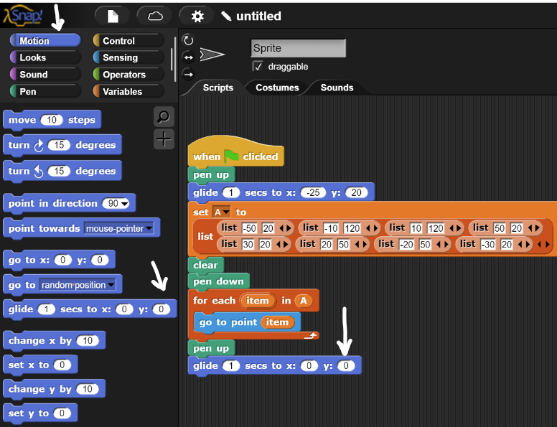

19. Click into the make a variable block when prompted variable name enter A2 and click okay. Once a variable is made, unclick the box on the left of the variable which will be stored in the left toolbar.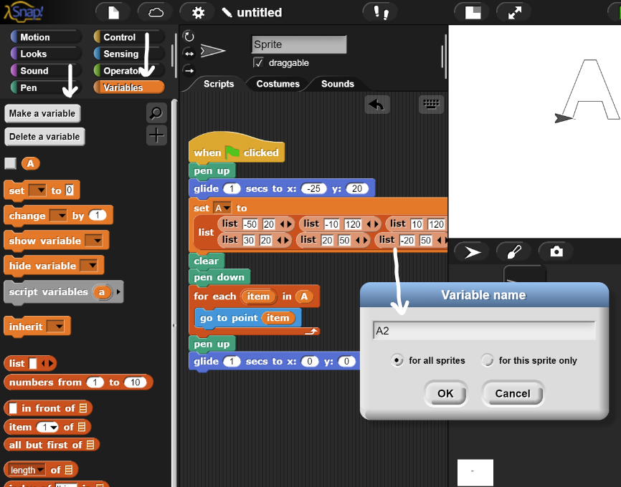

20. Click into the variables block and drag the set block to be connected to the glide block. When attached click on the upside arrow in the rectangle box on the right of the set block and change it to A2.

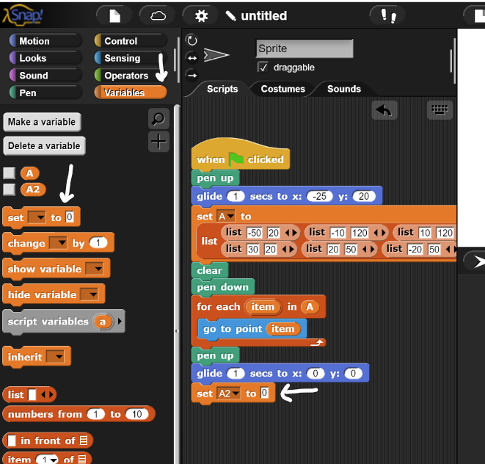

20. Click on the variable category and pull the list bubble in. Press the left arrow 4 times. Then place the list bubble made in the 0 place in the set block.

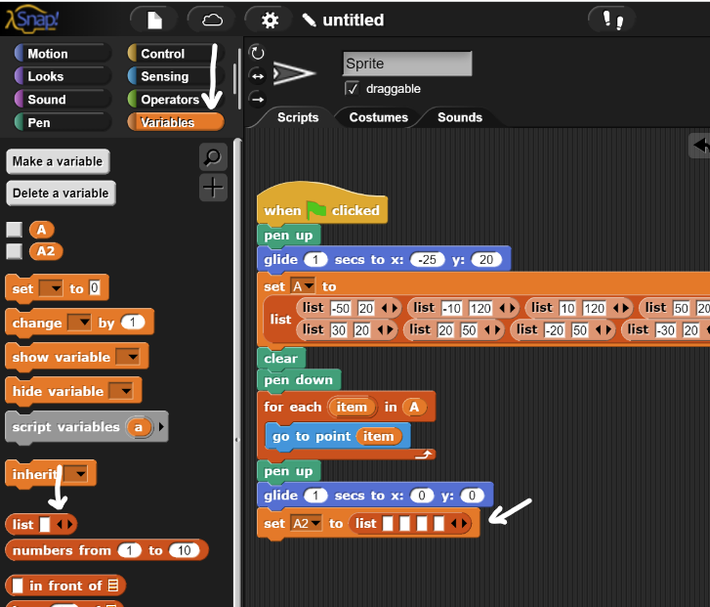

21. Click on the variable category and pull the list bubble in the center console. Press the right arrow to make two rectangles on the right of the list.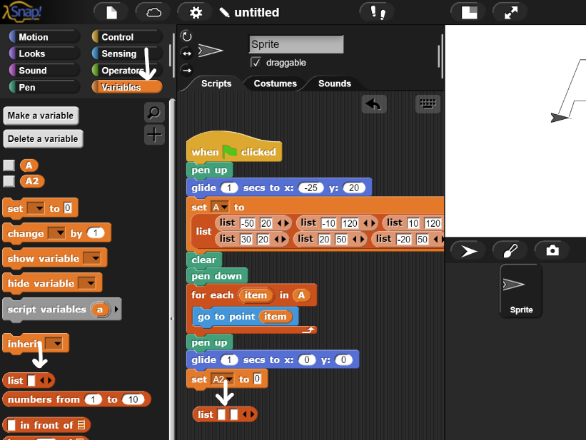

22. Go on the list bubble and right click on the bubble and press duplicate to make 3 more of the blocks.

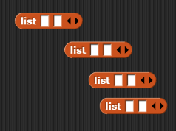

23. Drag each list into the 8 spaces made into step 20.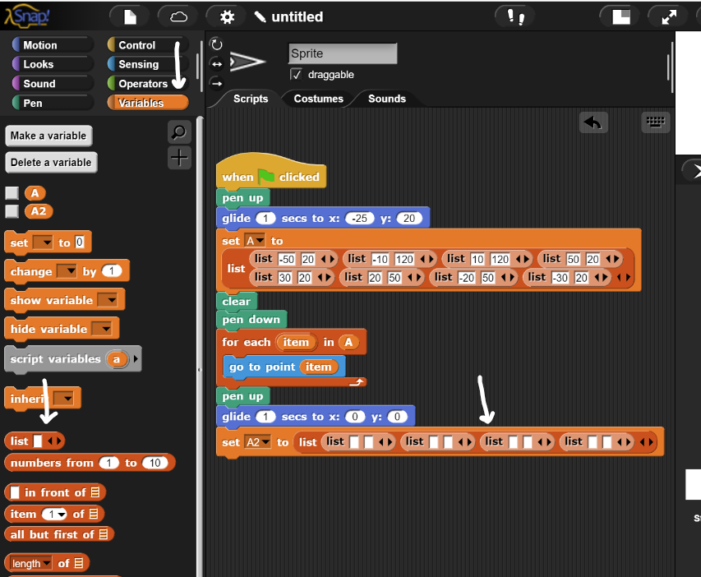

24. In each of the blanks fill in the values picture below. Starting from left to right 0, 100, -10, 70, 10, 70, 0, 100.

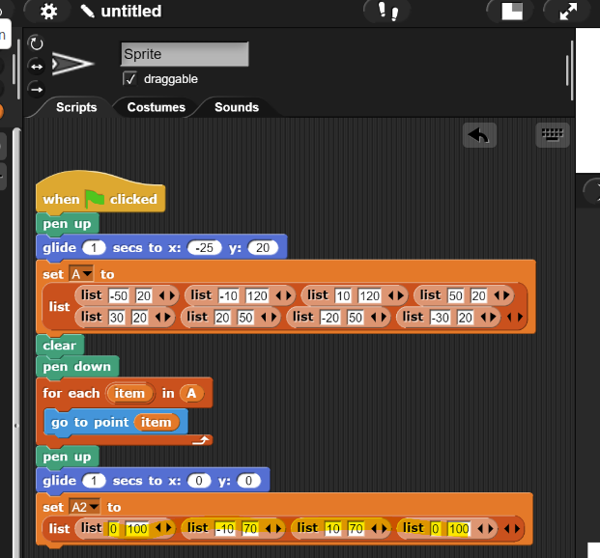

25. Then go into the pen category and drag the pen up block to attach to the set A2 block.

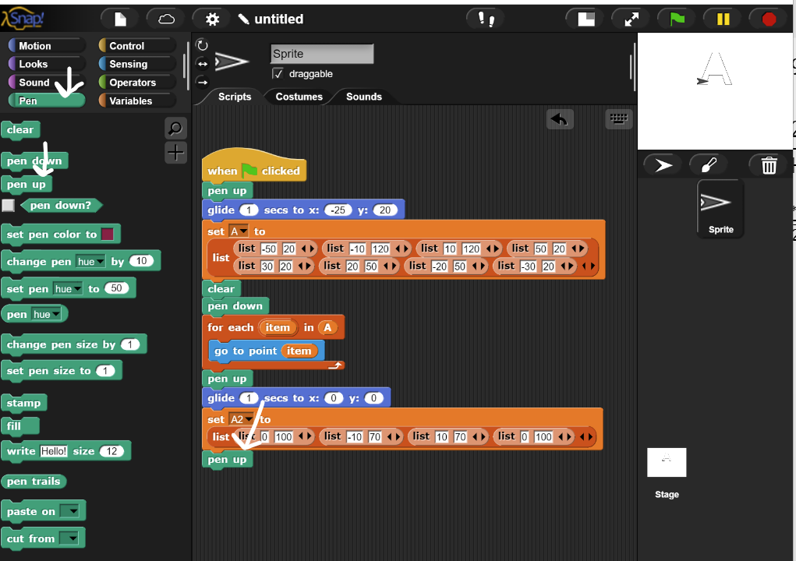

26. Go into the motion category and drag the glide block to go after the pen up block.

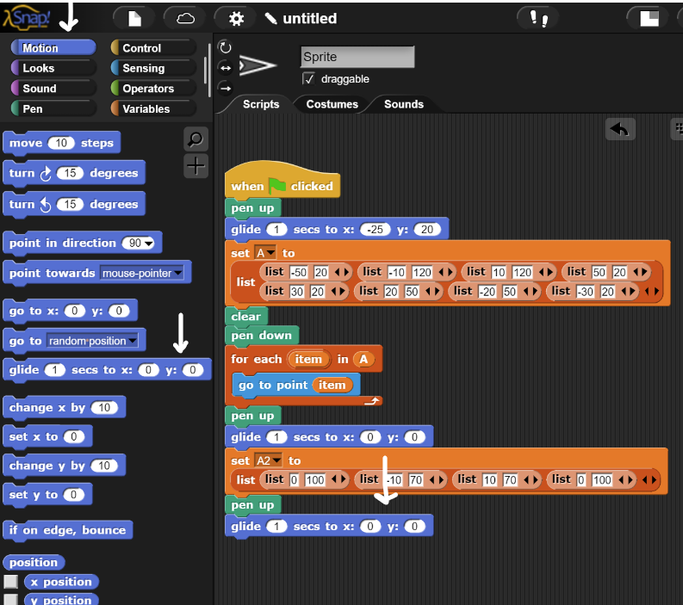

27. Then go into the variable category and attach a for each item block after the glide block.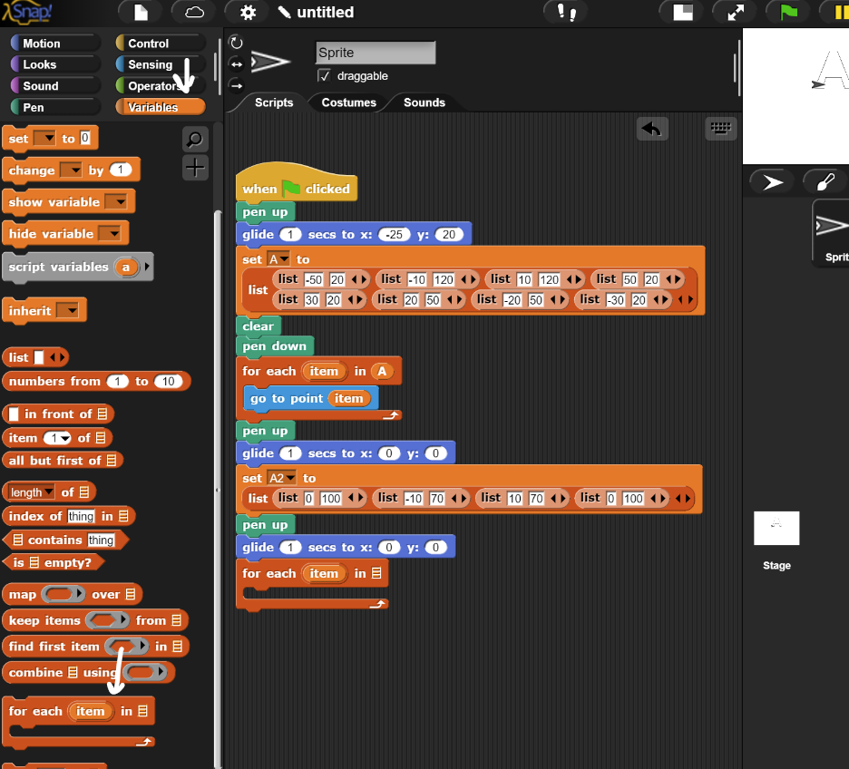

28. Drag the A2 variable that is stored in the variable category into the rectangle that is in the for each block.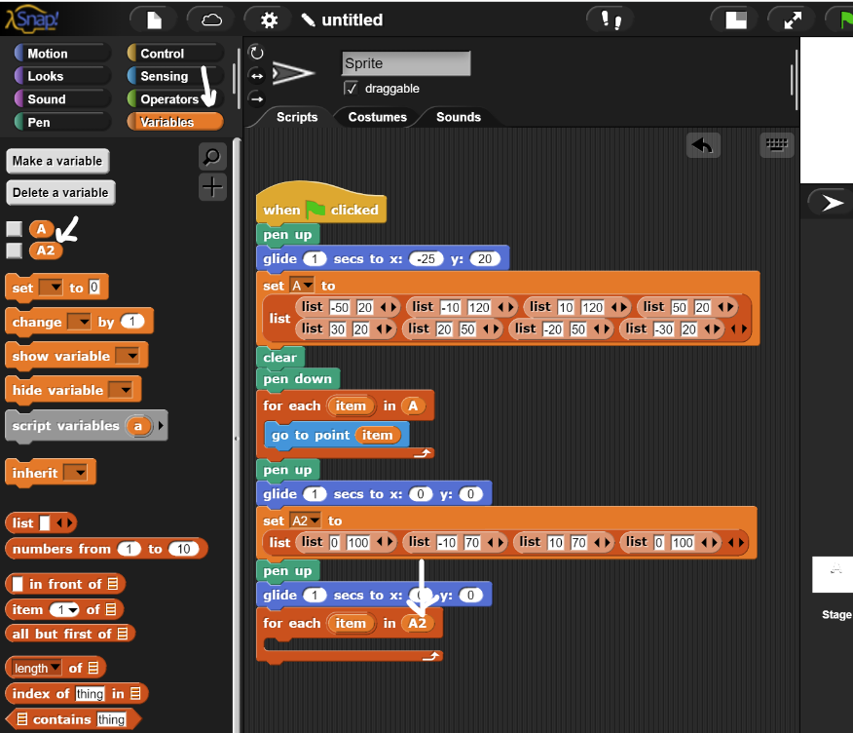

29. Go to the part of the code where we made the go to point item and right click on the block and select duplicate. Take the duplicated block and drag it in for each loop.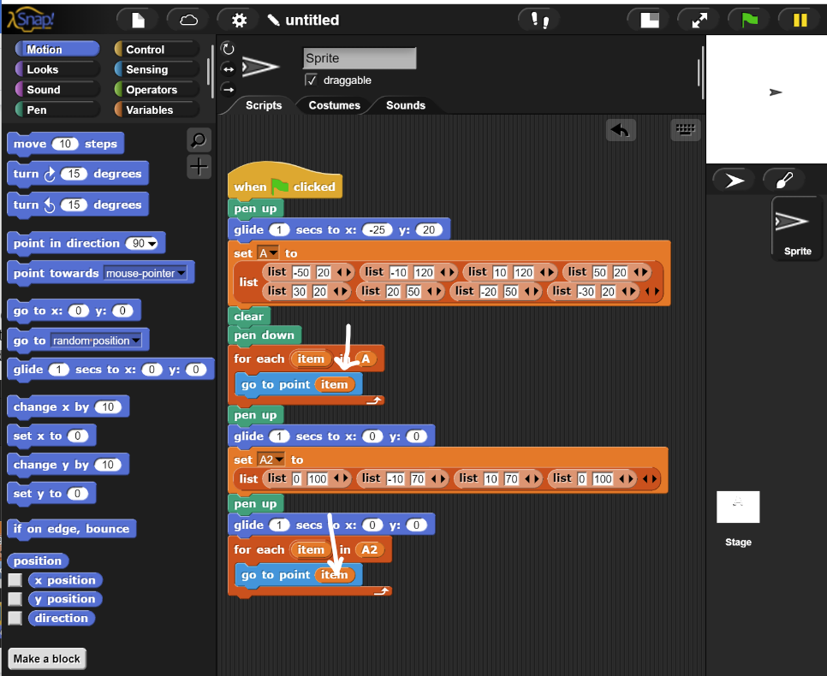

30. Go into the pen category and drag a pen down block to fall after the go to point item block inside the for loop.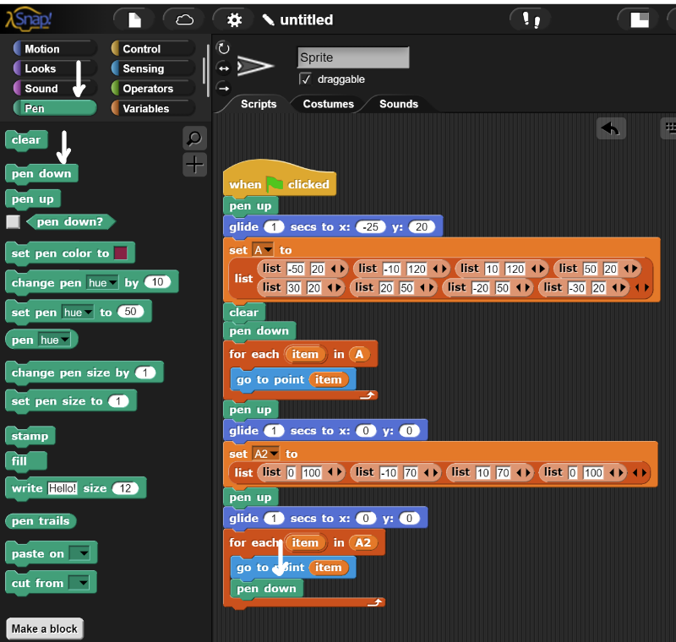

Final Snippet of Code:

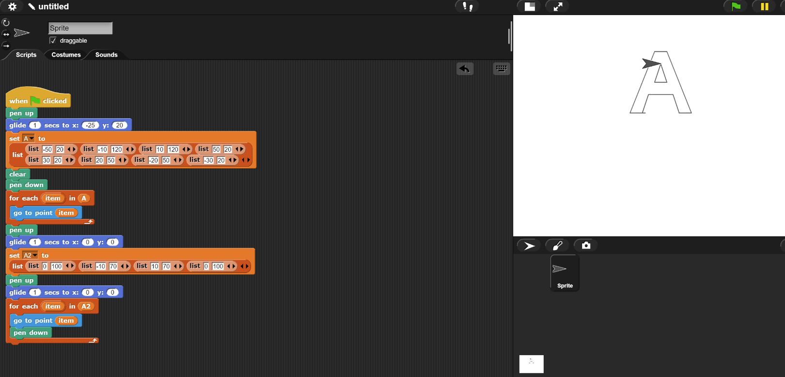

Snippet of go to point block:

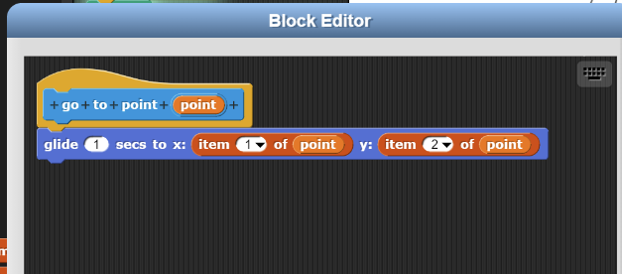

To make an account press on the cloud, press sign up, fill your information in below, agree to the contract and press okay. You will get a link in your email you use in the signup and have to verify through the link.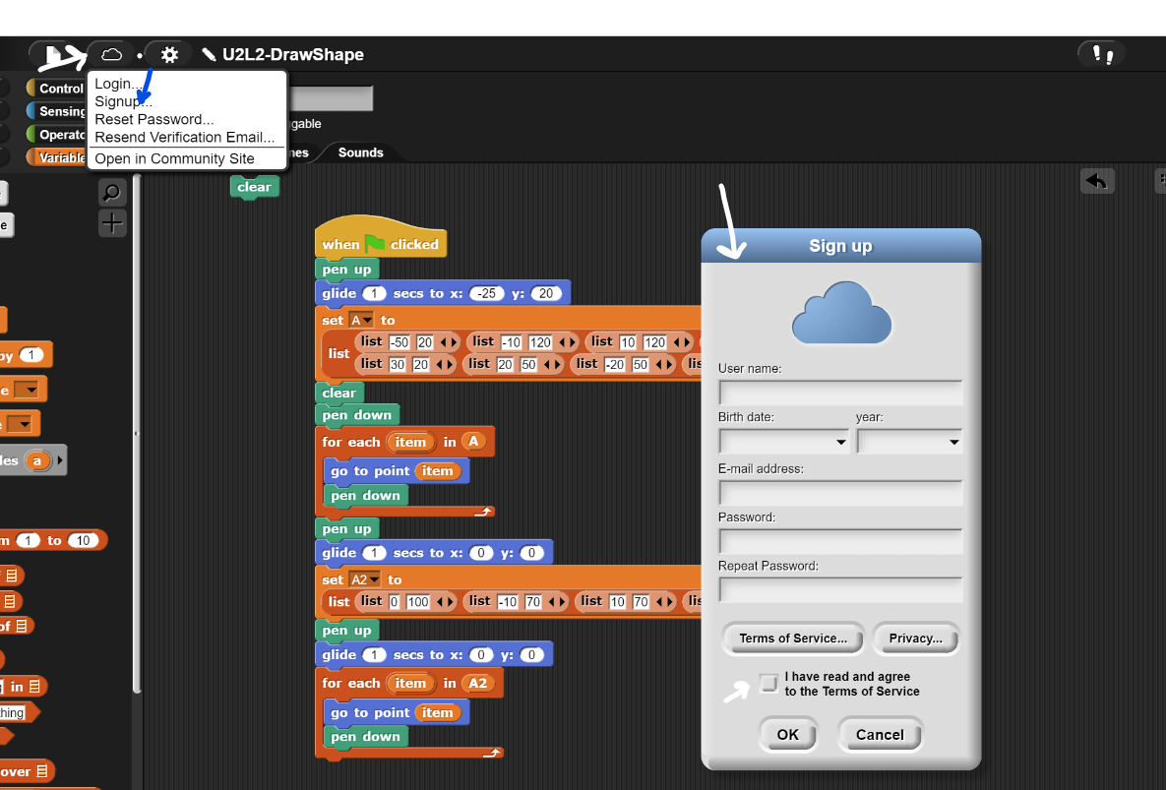

After verifying the account through your email click on the cloud again, and sign in with the username credential you have selected.

Once logged in click on the pages and select save as.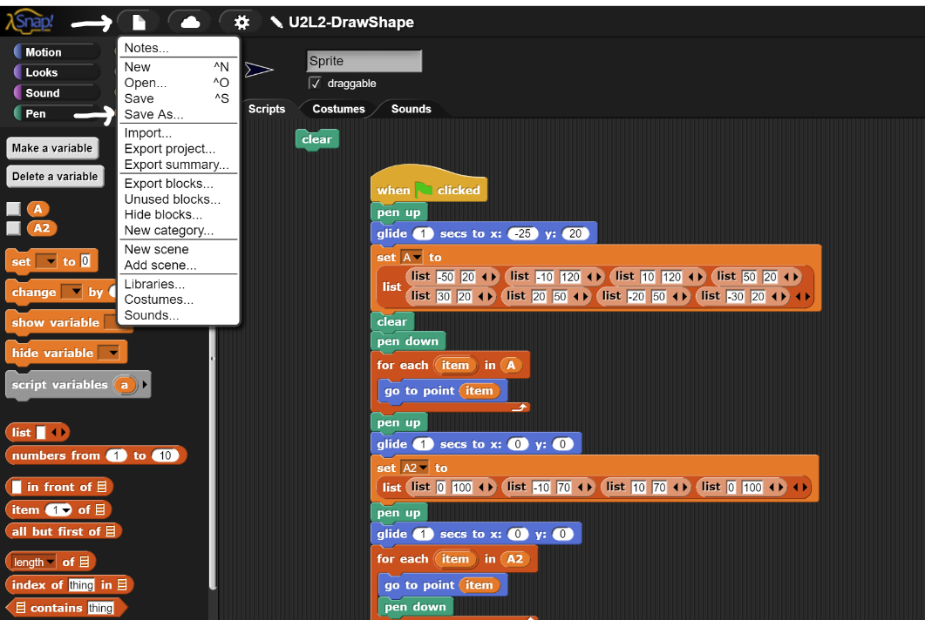

Enter a name in the text box and click on save. It will appear in list when successfully saved.

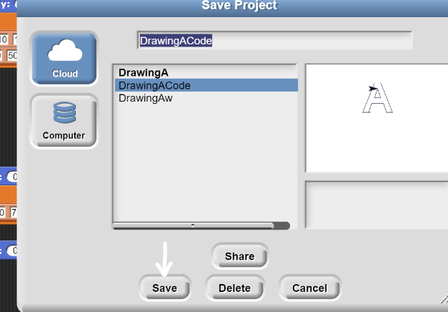

After it has been saved then click on the name in the list and press share to make it a public link. When prompted if you want to share select yes.